Start the Tool

1. Open the application (ExcelPOS.exe)

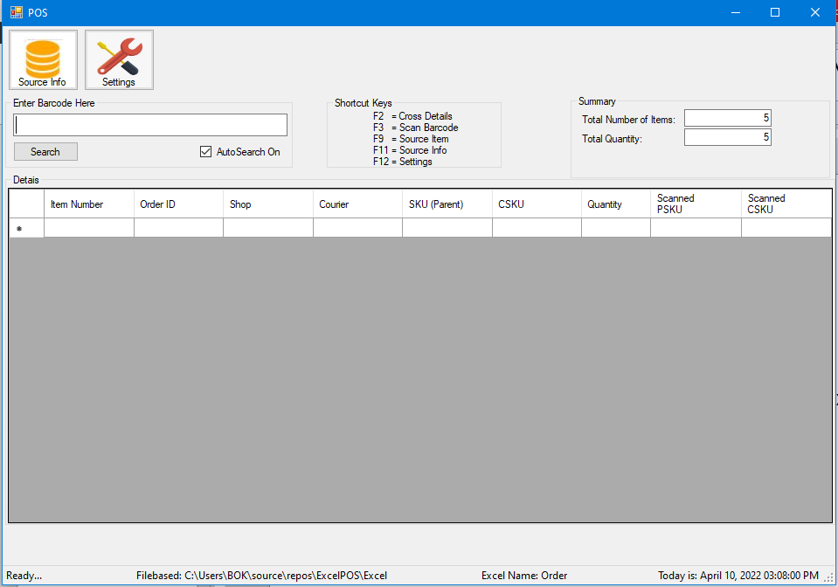

1. The tool is waiting for Barcode Input (Waybill) (SAMPLE Barcode only) – must be found on your excel input.

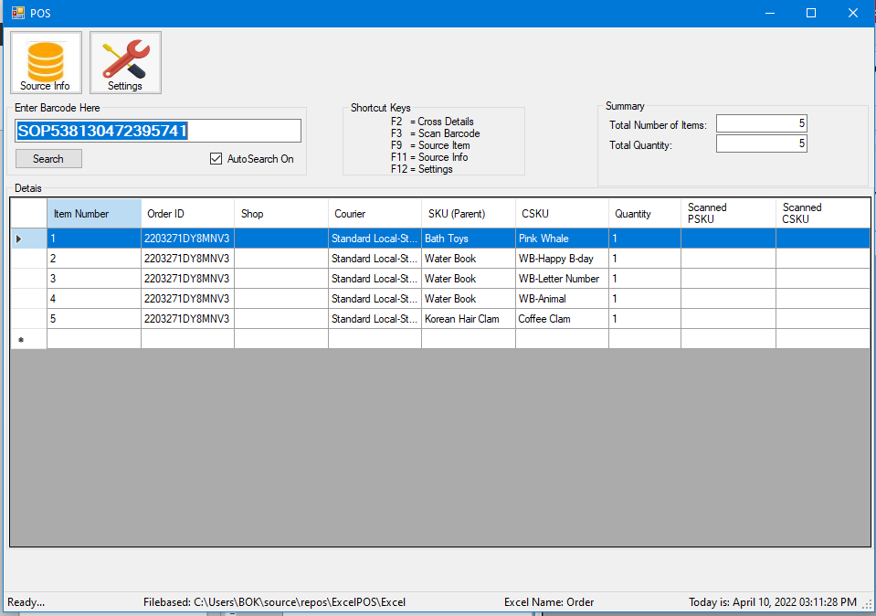

1. Press F2 for Item Checker

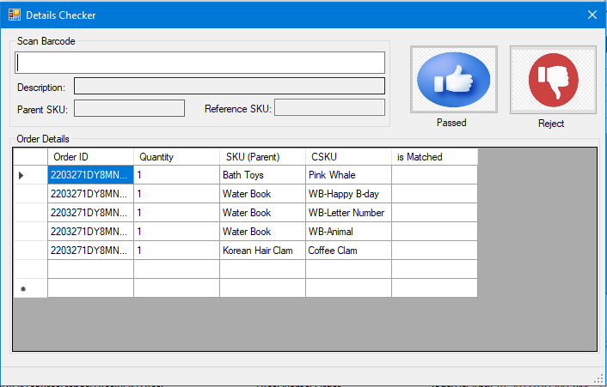

1. Scan the Item Barcode that you have for each items (make sure that it was exact value for SKU (Parent) and CSKU. We have also Management for Items Barcode (press F9 = Source Item)

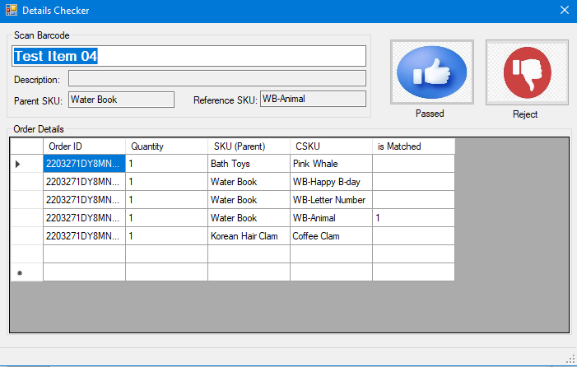

1. Checker will increment 1 Quantity on is Matched Column (as soon as it will matched on Quantity Column), if the scanned item is greater than quantity the tool will prompt an error and you may scan again.

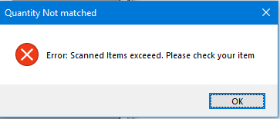

1. As soon as the quantity order was completed automatically it will enabled “Passed” button which will now proceed to next process. (To be discuss)

**Item Management**

1. Press F9 to open the form

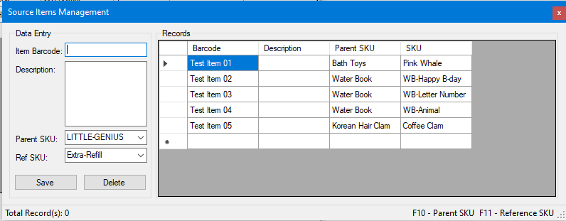

1. You may add another Barcode on this module. Just enter the value needed and press “Save” button.
2. If your Parent SKU or Ref SKU is not found on dropdown, you may press F10 = Parent SKU or F11 for Reference SKU. And you may also manually input it but it will not save as long as you will add this via F10/F11 shortcut.
3. For Delete Items (this will be to be discuss) if data will be deleted or not.

New Updates

1. Adding Passed Items (for Out Report)
2. Export data to Excel

**For Out Report**

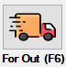

1. Press “F6”, make sure you already have your “Passed” item saved into data file. By pressing “Passed Button” on “Cross-Detail Module(F2)

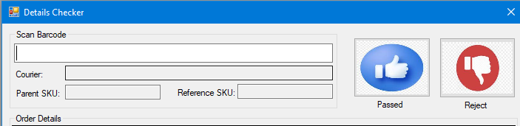

1. Upon clicking this button. The tool will save the output file/raw data to “Report” Folder in where the application was found. Or you may customized this by adding (just remove “;”)



1. For Out Report Module

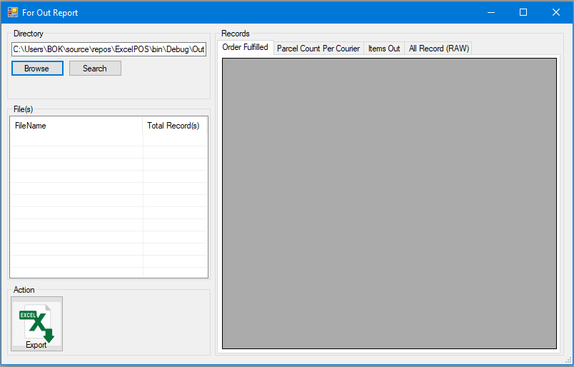

1. (You may browse your folder file or use as default (no need to press “Browse” button.
2. Click “Search” button and the tool will check for excel file
3. List of available file

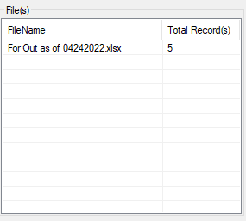

1. You can double click the Filename available to view the data you generate

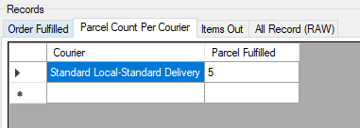

1. Then to save it on excel you can press “Export” Button

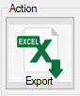

-if you have a problem, you may ask me so that I could guide you how to use it.

Revision History

|  |  |  |
| --- | --- | --- |
| Revision # | Revised By | Date |
| 1 | C.Biagtan | 04/10/2022 |
| 2 | C.Biagtan | 04/24/2022 |